

Functional Specification Documentation
(Phase 2)

PricewaterhouseCoopers

Version No.: 1.0
Date: 13-Jan -16

Table of Content
1. BP creation and approval 1
2 competitive quotes 5
3 T & C for PO 6
4 Reminders in po for gts and ogc items 6

Create, Update and Approval of BP Master Data

  - Overview

- Only authorize sap user can create/update BP master Data and set to inactive by default
- Only authorize user can review and activate BP master data

2.2 Set-up and configurations
- Create new field (UDF) in user set-up table (OUSR) PWCL database to flag user if authorize to create and update or approve BP master data
UDF Name : AB_AUTHORIZATION
Selection List :
- Approve
- Create and Update
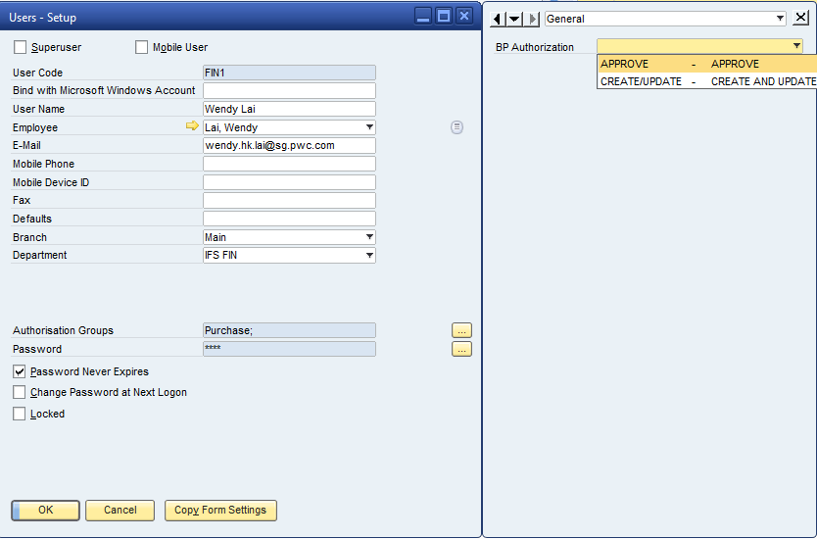

  - Select APPROVE if user is authorize to Approve BP master data
  - Select CREATE AND UPDATE if user is authorize to Create and Update BP master data
  - Update of UDF is only in PWCL database

- Create new field (UDF) in BP master data table (OCRD) PWCL
UDF Name : AB_STATUS
Selection List :
- Pending
- Approved

2.3 Process Details
- Create/update BP master data
  - Authorize user create or update new BP master as per procedure
  - Program to set AB_STATUS field to “Pending” if user is flag as “Create and Update” in BP Authorization field in OUSR table

  - When all details are entered and BP is added, set status to “InActive”

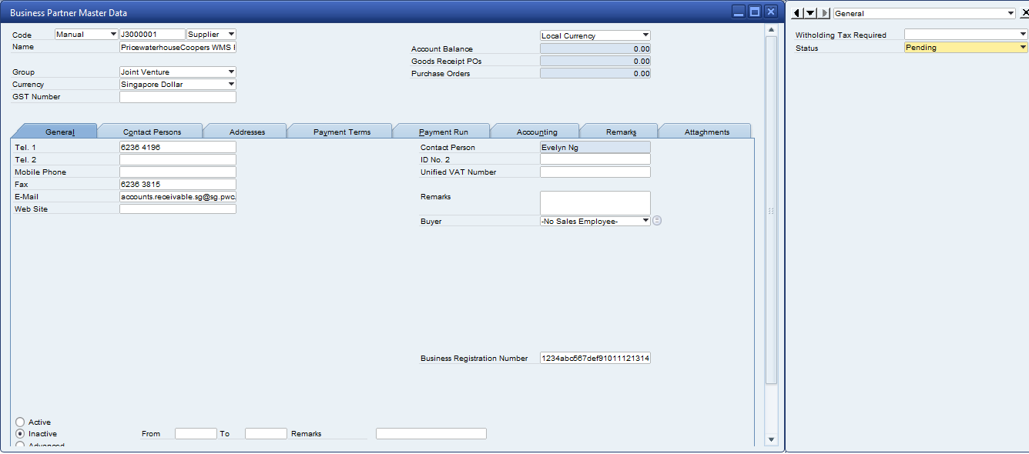

  - Send notification via alert from SAP to user authorized to approve BP new master data
  - Authorize approver check and change status field to “ Approved” to signify review and approval of BP

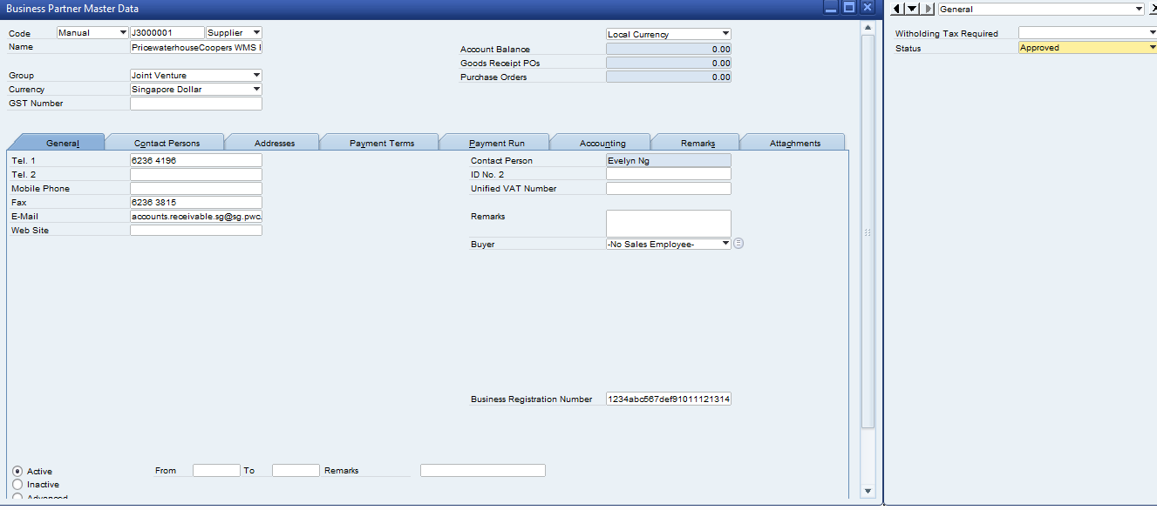

  - Click “Update to saved and program will auto update BP to “Active”

Competitive Quotes

2.1 Overview process

- Mandatory to get 3 quotation for PO with amount 10k and above
  - Quotation 1 Amount and supplier and Quotation 2 and supplier Amount are required fields when PO is greater than 10k
  - Field names
    - AB_PQ1AMT
    - AB_PQ_SUP1
    - AB_PQ2AMT
    - AB_PQ_SUP2
- Remove existing control validation in PO document for 10k and 50k. Keep validation control for PO amount greater than 10k only(refer to above)
- Set Waiver Description (AB_WAIVER) field as mandatory if Quotation 2 & 3 are blank. Block PO if waiver description is null. And display system message : “Please ensure quotation 2 & 3 are filled up. Mandatory to source 3 quotes for PO amount greater than 10k
- Set Remarks (OPOR.Comments) field as mandatory for PO amount greater than 10k
- Validate quotation supplier 2 & 3, if the same amount block PO creation and display system message as “Please ensure quotes have been obtained from 3 different suppliers. Mandatory to source for 3 quotes for PO amount greater than 10k”
- Trigger to next level approval for no competitive quote using same grid.
  - If quotation 2 and 3 are null and waiver description field is not null then, trigger the approval using the AB_WAIVERAPPROVAL table, approval procedure will be the as the existing program just that WaiverApproval table is used instead of standard approval template

2.2 Set-up and configuration
- Change field name for the following:
- Quotation 1 - Amount change to Quotation 2 - Amount
- Quotation 1-Supplier Name change to Quotation 2-Supplier Name
- Quotation2 – Amount change to Quotation 3 Amount
- Quotation 2 - Supplier Name change to Quotation 3-Supplier Name
- Shift Waiver description field to main screen
- Create new table “ Waiver Approval Table
  - Table Name : AB_WAIVERAPPROVAL

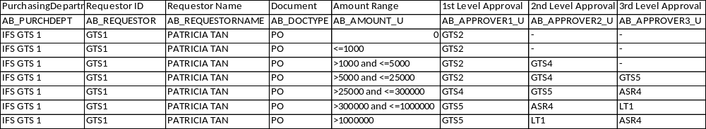

Terms and Conditions for PO

  - Overview Process

- Update Purchase order format to include Terms and Conditions when printed or sent out to supplier.

T & C To be advise waiting for submission from PWC.

4. Reminders in PO for GTS and OGC Items

  - Overview Process

To be advise waiting for the reminders note from PWC.

